


VISVESVARAYA TECHNOLOGICAL UNIVERSITY BELAGAVI-590014

FULL STACK DEVELOPMENT LAB- BCS406

A Project Report On

CODEMEDIC++:A CHANGE AWARE EXPLAINABLE AI-BASED BUG DETECTION AND AUTO-FIX SYSTEM
A Project report submitted in partial fulfillment of the requirements for the IV Semester degree of
Bachelor of Engineering in Computer Science and Engineering
Affiliated to
Visvesvaraya Technological University, Belagavi.
Submitted by

Saniya Mizba 1DT24CS237
Shaik Shehnaz 1DT24CS247
Shreya V 1DT24CS259
Srushti Ashok Naik 1DT24CS289 Under the Guidance of
Shilpa M
Assistant Professor
Computer Science and Engineering
Dayananda Sagar Academy of Technology & Management

Department of Computer Science and Engineering
DAYANANDA SAGAR ACADEMY OF TECHNOLOGY AND MANAGEMENT
Udayapura, Kanakapura Road, Bangalore-560082

2025-2026

DEPARTMENT OF COMPUTER SCIENCE & ENGINEERING

CERTIFICATE

Certified the project work entitled CODEMEDIC++:A Change Aware Explainable Ai-Based Bug Detection And Auto-Fix System carried out by Ms. Saniya Mizba bearing USN 1DT24CS237, Ms. Shaik Shehnaz bearing USN 1DT24CS247, Ms. Shreya V bearing USN 1DT242CS259 and Ms. Srushti Ashok Naik bearing USN 1DT24CS289 Bonafide students of Dayananda Sagar Academy of Technology and Management in partial fulfilment for the award of Bachelor of Engineering in Computer Science and Engineering of the Visvesvaraya Technological University, Belagavi during the year 2025-
26. It is certified that all corrections/suggestions indicated for the Internal Assessment have been incorporated in the report deposited in the departmental library. The project report has been approved as it satisfies the academic requirements concerning the project work prescribed for the said degree.

Shilpa M Assistant Professor
Dr. C Nandini Professor & HOD,
Dr. M. Ravishankar Principal,

Dept. of CSE, DSATM Dept. of CSE, DSATM DSATM


External Examiners Sl.
No.
1.

2.

Name Signature with Date



DEPARTMENT OF COMPUTER SCIENCE & ENGINEERING

DECLARATION

We, Saniya Mizba [USN:1DT24CS237], Shaik Shehnaz [USN:1DT24CS247], Shreya V [USN: 1DT24CS259] and Srushti Ashok Naik [USN: 1DT24CS289], students of IV Semester B.E., in Computer Science and Engineering, Dayananda Sagar Academy of Technology & Management hereby declare that the Mini Project entitled “CODEMEDIC++:A Change Aware Explainable Ai-Based Bug Detection And Auto-Fix System” has been carried out by us and submitted in partial fulfillment of the requirements for the IV Semester degree of Bachelor of Engineering in Computer Science and Engineering from Dayananda Sagar Academy of Technology and Management during academic year 2025-2026.

Sl. No | Name | USN | Signature with Date
1 | Saniya Mizba | 1DT24CS237
2 | Shaik Shehnaz | 1DT24CS247
3 | Shreya V | 1DT24CS259
4 | Srushti Ashok Naik | 1DT24CS289

ACKNOWLEDGEMENT

We are thankful to Dr. M. Ravishankar, Principal, DSATM, Bangalore, for providing the necessary facilities and for the encouragement to carry out the Project in DSATM.

We express our humble gratitude and thanks to Dr. C Nandini, Professor and HOD, Computer Science and Engineering, DSATM, for guiding us and facilitating us to complete the Project successfully.

We are very thankful to our guide, Shilpa M, Associate Professor, Department of Computer Science and Engineering, DSATM, for her constant encouragement, guidance, and support throughout the Project, without whose efforts this would not have been possible.

We thank the Project Coordinators, Dr. Kavitha, Mr. Parvathisha Pudugosula, Ms. Deepthi and Mr. Kondeti Dilip Kumar, Mr. Nunna Rama Chandu for their invaluable critical reviews, guidance, and support in completing the project on time.

We finally thank all the Technical Staff for their support and help while carrying out the project. Last but not least, we wish to thank our friends and parents, who have been encouraging and inspiring us throughout the project's execution.

Name USN
Saniya Mizba 1DT24CS237
Shaik Shehnaz 1DT24CS247
Shreya V 1DT24CS259
Srushti Ashok Naik 1DT24CS289

ABSTRACT

This project presents a real-time assistive communication system designed to bridge the communication gap for individuals with dual sensory impairments by translating sign language gestures into Braille representations. The proposed framework integrates computer vision techniques with machine learning and web technologies to achieve high accuracy and low latency in gesture recognition and translation. A custom dataset comprising ten commonly used sign language gestures - Call, Friend, Ok, Pinch, Victory, Help, Home, Super, You, and Sleep was collected under varying environmental conditions to ensure robustness. Using MediaPipe, key hand landmarks were extracted and used to train a Support Vector Machine (SVM) classifier for gesture recognition. The recognized gestures are then converted into their corresponding Braille patterns and displayed through an interactive web interface for accessibility. To benchmark performance, models such as Convolutional Neural Network (CNN) and You Only Look Once (YOLO) were also evaluated; however, SVM was chosen as the final model due to its lightweight design, interpretability, and real- time response efficiency. Experimental results demonstrated a high classification accuracy of 97.5% and a strong F1-score, validating the system’s reliability and effectiveness in real-time assistive communication. The proposed system holds significant potential in enhancing inclusivity by enabling seamless interaction for individuals with Hearing and visual impairments.

CONTENTS

Chapter No | Chapter Name | Page No
 | Abstract
 | List of Figures
 | List of Tables
1 | Introduction | 1
2 | Literature Survey | 2
3 | Methodology & Proposed System | 6
4 | System Requirements Specification | 11
5 | System Design | 15
6 | Implementation | 18
7 | System Testing | 32
8 | Results | 33
9 | Snapshots | 36
10 | Conclusion and Future Enhancement | 39
11 | References | 41
12 | Annexure – I
13 | Copy of the Research Paper

Figure No | Figure Caption | Page No
3.2.1 | Proposed System | 9
5.1 | System Architecture | 15
6.5.1 | User Registration Interface | 21
6.5.2 | Description of Sign2Braille Interface | 21
6.5.3 | User Dashboard Interface | 22
6.5.4 | Real-Time Detection of the Gesture "Home" | 23
6.5.5 | Detection History and Model Status Interface | 23
8.4.1 | Sign Language Recognition and Braille Outputs | 36
8.4.2 | Model Detection and Storage History | 38

Table No | Table Caption | Page No
3.1.1 | Existing Braille and Sign Recognition Platforms | 6
4.1 | Software Requirements | 11
6.4.1 | Files overview | 20
7.1.1 | Summary of Testing Phases and Outcomes | 32
8.2.1 | Performance metrics of SVM-based Sign  Language Recognition model | 34
8.5.1 | Comparison of Model Performance for Sign  Language Recognition | 35

CHAPTER 1
INTRODUCTION

Software development has become an essential part of modern technology, powering applications used in education, healthcare, business, finance, and communication. As software systems grow in complexity, identifying and fixing programming errors becomes increasingly challenging. Debugging is one of the most time-consuming phases of software development, often requiring developers to spend significant effort locating bugs and implementing appropriate fixes.
Traditional debugging methods rely heavily on manual code inspection, compiler messages, and testing tools. While these approaches are useful, they may not always provide detailed explanations or effective solutions for identified errors. Recent advancements in Artificial Intelligence (AI) and Large Language Models (LLMs) have created new opportunities for automated code analysis and intelligent bug detection. AI-powered systems can understand programming logic, identify coding mistakes, and generate meaningful suggestions to improve code quality.
CodeMedic is a full-stack AI-powered bug detection web application developed to simplify the debugging process. The system allows users to submit source code written in Python, C, C++, and Java through an interactive web interface. Once the code is submitted, the application analyzes it using the Groq API powered by the Llama 3.3 70B language model. The AI engine identifies bugs, classifies them based on their type, highlights the exact lines where errors occur, and provides detailed explanations along with recommended fixes.
The application is built using Django as the backend framework and PostgreSQL as the database management system. A CodeMirror-based editor provides syntax highlighting and line numbering, creating a user-friendly coding environment. Every analysis is stored in the database, enabling users to access previous reports through a personalized dashboard. Additional features such as PDF report generation, feedback collection, risk-level assessment, and administrative monitoring further enhance the usefulness of the platform.
The primary objective of CodeMedic is to assist developers in improving code quality and reducing debugging time through intelligent automation. By combining modern web technologies with advanced AI capabilities, the system provides an efficient and accessible solution for code analysis and software maintenance.

CHAPTER 2
LITERATURE SURVEY

[1] Data Mining Static Code Attributes to Learn Defect Predictors
T. Menzies, D. Greenwald, and A. Frank proposed a defect prediction approach using static code metrics and data mining techniques. The study focuses on identifying software modules that are more likely to contain defects by analyzing source code attributes such as complexity, size, coupling, and inheritance relationships. Machine learning algorithms were applied to classify software components and predict fault-prone areas before deployment. The objective was to reduce software failures and improve development efficiency.
The methodology involved collecting software metrics from previously developed software projects and applying data mining algorithms to classify modules as defective or non-defective. The researchers compared different prediction models and analyzed their effectiveness in identifying fault-prone areas. Their study demonstrated that historical software data can be effectively utilized to improve software quality and reduce debugging effort during development.
The experimental results demonstrated that code metrics can effectively identify defective modules and improve software quality. The proposed model helped reduce testing effort and maintenance cost by enabling developers to focus on high-risk components. The study also proved that automated defect prediction can support better software planning and resource allocation. This research highlights the importance of intelligent defect prediction in software engineering. The concepts presented in this paper are closely related to the proposed CodeMedic system, which automatically analyzes source code and detects bugs using Artificial Intelligence techniques.

[2] Mining Metrics to Predict Component Failures
N. Nagappan, T. Ball, and A. Zeller introduced a metric-based framework for predicting software component failures. The authors collected software metrics from large-scale projects and analyzed the relationship between code characteristics and software reliability. Various statistical models were used to estimate the likelihood of failures in different software components. The study focused on improving software dependability through early fault identification.

The results showed that software metrics provide valuable insights into software quality and can effectively identify modules with a high probability of failure. The proposed approach improved reliability prediction and assisted developers in making informed maintenance decisions. The study emphasized the importance of early defect detection in reducing maintenance costs and improving reliability.
The authors examined various software attributes and investigated how these metrics influence system reliability. Data collected from large industrial projects was used to train and evaluate prediction models. The study provided evidence that quantitative software measurements can be useful indicators of future software failures and maintenance requirements.
The findings support the concept of risk assessment used in CodeMedic, where detected bugs are categorized into different risk levels such as Safe, Low, Medium, High, and Critical to assist developers in prioritizing corrections.

[3] When Do Changes Induce Fixes?
S. Kim, T. Zimmermann, and A. Zeller investigated how software modifications introduce defects and trigger bug-fixing activities. The study analyzed software repositories and examined relationships between code changes and defect occurrence. By mining historical development data, the authors identified patterns that commonly lead to software failures. The research provided valuable insights into software evolution and maintenance practices.
The research focused on software repositories containing development histories and bug reports. By analyzing change patterns, the authors identified several factors that contribute to defect introduction. Their findings help software teams understand which development activities are more likely to affect software stability and quality.
The research demonstrated that certain code modifications are more likely to introduce bugs than others. Understanding these patterns helps developers improve coding practices and reduce defect rates. The proposed approach contributes significantly to software maintenance and defect prediction. The study also highlighted the importance of repository mining in identifying defect-prone code segments. Similar principles are applied in CodeMedic, where the system identifies problematic code sections and provides detailed explanations along with corrective suggestions to improve overall code quality.

[4] LineVul: A Transformer-Based Line-Level Vulnerability Detection Method
M. Fu, C. Tanthanthavorn, and W. Wang proposed LineVul, a Transformer-based vulnerability detection model designed to identify vulnerabilities at the line level in source code. Traditional vulnerability detection techniques often analyze complete files and fail to locate the exact source of the problem. To overcome this limitation, the authors developed a deep learning framework capable of detecting vulnerable lines with high precision. The model utilizes Transformer architecture to understand the contextual relationships present in source code.
Experimental evaluation showed that LineVul achieved superior performance compared to conventional machine learning approaches.
The model successfully identified vulnerable code locations while reducing false positives. The ability to highlight exact lines containing vulnerabilities makes this work highly relevant to CodeMedic. The framework demonstrated improved accuracy and efficiency in software vulnerability detection tasks. Similar to LineVul, the proposed system detects bugs, highlights the affected lines, and provides fix suggestions for developers.

[5] Defective Vulnerability Identification in Source Code with Graph Neural Networks
Z. Zhou, S. Liu, M. Zhou, Q. Wang, and T. Zhang proposed a Graph Neural Network (GNN)-based framework for vulnerability detection in source code. The model captures structural relationships between program components and learns complex coding patterns associated with software defects. Unlike traditional methods, the GNN approach considers both syntax and semantic information during analysis. This enables more effective understanding of source code structure and behavior.
The experimental results demonstrated improved vulnerability detection accuracy compared to several existing machine learning techniques. The study highlights the growing importance of Artificial Intelligence in software quality assurance and code analysis. The proposed framework achieved better performance in identifying hidden vulnerabilities and software weaknesses. This research is closely related to CodeMedic because both systems utilize advanced AI models to analyze source code, detect bugs, classify issues, and provide recommendations to improve software reliability and maintainability.

CHAPTER 3

METHODOLOGY AND PROPOSED SYSTEM

Existing System

Table 3.1.1 Existing Braille and Sign Recognition Platforms

Disadvantages of Existing Bug Detection and Code Analysis Platforms

1. Limited Error Explanation:
Most existing tools identify errors and vulnerabilities but fail to provide detailed explanations and beginner-friendly guidance for resolving them.

2. No Unified Debugging Solution:
Many platforms focus only on syntax checking, vulnerability scanning, or code suggestions instead of providing a complete bug detection and debugging system.

3. Manual Debugging Effort:
IDE-based debugging tools require developers to manually inspect code, trace errors, and determine suitable fixes, which increases development time.

4. Lack of Accurate Risk Assessment:
Existing systems generally do not calculate an overall risk level based on the number and severity of detected bugs, making prioritization difficult.

5. Limited Multi-Language Support:
Several debugging tools are optimized for specific programming languages and may not efficiently support multiple programming environments.

6. Absence of Analysis History:
Many platforms do not maintain records of previous code analyses, making it difficult for users to track debugging progress and past reports.

7. Lack of User Feedback Mechanism:
Most systems do not collect user feedback regarding bug detection accuracy, limiting opportunities for continuous improvement of the platform.

8. No Integrated Reporting and Dashboard:
Existing tools often lack features such as PDF report generation, personalized dashboards, statistics tracking, and centralized management of debugging sessions.

Proposed System

The proposed system introduces an AI-powered web platform that automatically detects bugs and vulnerabilities in source code without requiring complex manual debugging procedures. Existing debugging tools often focus only on syntax checking or require developers to spend significant time identifying errors. To overcome these limitations, CodeMedic uses the Groq API powered by the Llama 3.3 70B model for intelligent bug detection and analysis. Once the code is analyzed, the system identifies bugs, classifies them by type, highlights the affected lines, and provides detailed fix suggestions through a Django-based web interface.
A structured analysis workflow was designed to ensure accurate bug detection across multiple programming languages. Previous studies have highlighted the importance of Artificial Intelligence and Machine Learning in software defect prediction and vulnerability detection. Following this approach, CodeMedic supports Python, C, C++, and Java source code. Users can enter their code through a CodeMirror-based editor, which provides syntax highlighting, line numbering, and real-time editing support. The system also enforces a 100-line code limit to maintain efficient processing and response times.
Each submitted program is securely transferred to the AI engine for analysis. The Groq-powered Llama model processes the source code and returns a structured response containing detected bugs, bug type, line number, error description, and recommended fixes. The results are then validated and stored in the PostgreSQL database. Each analysis session is associated with a user account and contains information such as programming language, source code, risk level, error count, and timestamp. This enables users to maintain a complete history of previous analyses.
After code submission, the AI engine performs bug detection and generates a detailed report. The generated report contains:
• Line number of the detected bug
• Bug type and category
• Error description
• Recommended fix suggestion
• Overall risk level

The collected bug information contributes to accurate code analysis and improved debugging efficiency. The risk level is calculated based on the number and severity of detected bugs, helping developers prioritize corrections and improve software reliability.
The overall operation of the system is shown in Figure 3.2.1 through a Data Flow Diagram. The process begins when the user enters source code into the CodeMirror editor. The submitted code is passed to the Django backend, which communicates with the Groq AI engine for bug analysis.
After processing, the AI-generated results are returned to the application for display. The detected bugs are highlighted within the editor, and detailed bug reports are presented on the dashboard. Users can provide feedback on the accuracy of each bug report and export the results as a PDF document. This architecture enables fast, accurate, and practical bug detection while providing a user-friendly experience for students, beginners, and professional developers.

Figure 3.2.1 Proposed System

Advantages of the Proposed Support System

1. End-to-End AI-Powered Debugging Platform:
The system integrates code submission, bug detection, bug classification, risk assessment, and report generation into a single platform.
2. Multi-Language Support:
Supports multiple programming languages including Python, C, C++, and Java, making it suitable for a wide range of developers.
3. AI-Based Bug Detection:
Utilizes the Groq API powered by the Llama 3.3 70B model to identify bugs, vulnerabilities, and coding issues with high accuracy.
4. Exact Line-Level Error Identification:
Highlights the precise lines containing bugs, helping developers quickly locate and resolve issues.
5. Detailed Bug Explanation and Fix Suggestions:
Provides comprehensive bug descriptions along with recommended solutions, making debugging easier for beginners and professionals.
6. Risk Level Assessment:
Calculates overall project risk levels such as Safe, Low, Medium, High, and Critical based on detected bugs and their severity.
7. Personalized Dashboard and History Tracking:
Stores all analysis sessions in a PostgreSQL database, allowing users to view previous reports and debugging history.
8. PDF Report Generation:
Enables users to export detailed bug analysis reports in PDF format for documentation and future reference.
9. User Feedback Integration:
Allows users to provide feedback on bug detection accuracy, supporting future improvements to the system.
10. User-Friendly Web Interface:
The Django-based web application provides an intuitive interface with syntax highlighting, line numbering, dark/light themes, and easy navigation for efficient code analysis.

CHAPTER 4

SYSTEM REQUIREMENTS SPECIFICATION

The success of the CodeMedic AI-Powered Bug Detection System depends on well-defined hardware and software requirements, along with functional and non-functional specifications. These requirements ensure that the system operates efficiently, accurately, and provides a user-friendly environment for developers to analyze source code and identify bugs.

4.1 Software Requirements
The software stack includes development frameworks, Artificial Intelligence services, database technologies, and web technologies required to implement bug detection, report generation, and dashboard functionalities.
The Django framework serves as the backend, handling user authentication, API requests, database operations, and communication with the AI engine. The Groq API powered by the Llama 3.3 70B model performs intelligent code analysis and bug detection. PostgreSQL is used for storing user data, analysis history, bug reports, and feedback information. CodeMirror provides syntax highlighting and code editing capabilities, while jsPDF supports PDF report generation.
Table 4.1 Software Requirements
Software Component Type | Technology / Tool Used
Programming Language | Python 3.12
Backend Framework | Django 4.2
Front-End Technologies | HTML, CSS, JavaScript, jQuery
Code Editor | CodeMirror 5
Artificial Intelligence Engine | Groq API (Llama 3.3 70B)
Database | PostgreSQL 16
PDF Generation | jsPDF
Authentication System | Django Built-in Authentication
Static File Management | WhiteNoise
Version Control | Git and GitHub
Deployment Platform | Render + Gunicorn

4.2 Functional Requirements

The proposed CodeMedic system is designed to perform multiple coordinated functions to ensure accurate bug detection, code analysis, and fix recommendation for software developers.
- Code Input:
Allow users to enter or paste source code written in Python, C, C++, or Java through an interactive code editor.
- User Authentication:
Provide secure user registration, login, and session management using Django authentication.
- Code Validation:
Verify code length and programming language before submitting it for analysis.
- AI-Based Bug Detection:
Analyze source code using the Groq API powered by the Llama 3.3 70B model to identify bugs and vulnerabilities.
- Bug Classification:
Classify detected issues into different categories such as syntax errors, logical errors, runtime issues, and coding vulnerabilities.
- Line-Level Error Identification:
Highlight the exact lines containing bugs to simplify debugging and error correction.
- Fix Recommendation:
Generate detailed bug descriptions and recommended solutions for each detected issue.
- Risk Assessment:
Calculate the overall risk level (Safe, Low, Medium, High, or Critical) based on bug severity and count.
- Report Generation and Storage:
Store analysis history in the database and allow users to export bug reports as PDF documents.

4.3 Hardware Requirements
The CodeMedic system requires standard and easily available hardware components to ensure accessibility and efficient performance. The system can operate on a desktop or laptop with an Intel Core i3 processor or higher, 4 GB RAM, and at least 256 GB storage. For improved performance and faster processing, an Intel Core i5/i7 processor and 8 GB RAM are recommended.

A stable internet connection is required to communicate with the Groq AI service and access cloud-based functionalities. Since the system is web-based, users can access it through standard web browsers without requiring specialized hardware. The application supports Windows, Linux, and macOS operating systems capable of running modern web browsers.

4.3 Non-Functional Requirements
To ensure reliability, scalability, security, and usability, the system must satisfy the following non-functional requirements.
- Performance: The system should analyze source code and generate bug reports within a few seconds for normal-sized programs.
- Scalability: The architecture should support additional programming languages and future AI model upgrades.
- Usability: The web interface should be intuitive and easy to use for both beginners and professional developers.
- Reliability: The system should consistently provide accurate bug detection and stable operation under normal usage conditions.
- Portability: The application should function correctly across different operating systems and web browsers.
- Maintainability: The modular architecture should support easy updates, bug fixes, and feature enhancements.
- Security: User accounts, source code, and analysis data must be protected against unauthorized access.
- Availability: The system should remain accessible whenever users need to perform code analysis and debugging tasks.

CHAPTER 5
SYSTEM DESIGN

System Architecture
The System Architecture of the CodeMedic AI-Powered Bug Detection System defines the logical flow and organizational structure of the proposed intelligent debugging framework. The architecture combines modules for user authentication, code submission, AI-powered bug detection, bug classification, risk assessment, report generation, and dashboard management. The design emphasizes accuracy, scalability, usability, and real-time analysis, enabling developers to identify and resolve coding issues efficiently. The modular architecture also ensures easy maintenance and future expansion while supporting multiple programming languages.

Figure 5.1 System Architecture

The system architecture diagram is shown in Figure 5.1.1, which illustrates the complete workflow of source code analysis and bug detection. The major modules are described below:

5.1.1 User Authentication Module
The process begins with user authentication, where users can register and log in securely using the Django authentication system. This module manages user accounts, session handling, and access control. Authentication ensures that analysis history, bug reports, and user feedback remain secure and accessible only to authorized users.

5.1.2 Code Input and Editor Module
The CodeMirror-based editor serves as the primary interface for code submission. It supports Python, C, C++, and Java programming languages while providing syntax highlighting, line numbering, and real-time editing capabilities. The module validates the programming language and code length before forwarding the source code for analysis.

5.1.3 Code Validation and Processing Module
Before analysis, the submitted source code undergoes validation and preprocessing. The system verifies code format, selected language, and input constraints. This module ensures that only valid code is forwarded to the Artificial Intelligence engine, thereby improving processing efficiency and reducing unnecessary API requests.

5.1.4 AI-Powered Bug Detection Module
The bug detection module forms the core of the system. It utilizes the Groq API powered by the Llama 3.3 70B language model to analyze source code and identify bugs, vulnerabilities, logical errors, and coding issues. The AI engine understands programming syntax and context, enabling accurate detection of potential problems within the submitted code.

5.1.5 Bug Classification and Risk Assessment Module
After bug detection, the identified issues are categorized into different types such as syntax errors, logical errors, runtime errors, and security vulnerabilities. The system then calculates the overall risk level based on the number and severity of detected bugs. The risk level is classified as Safe, Low, Medium, High, or Critical to help developers prioritize corrections.

5.1.6 Database Management Module
The PostgreSQL database stores user information, analysis sessions, bug reports, feedback records, and risk assessment results. Each code analysis session is linked to the corresponding user account, allowing efficient storage and retrieval of debugging history. This module ensures data consistency and supports future analysis tracking.

5.1.7 Report Generation and Dashboard Module
The dashboard module presents bug reports, analysis statistics, and previous debugging sessions through a user-friendly interface. Users can review detailed bug descriptions, fix suggestions, and risk assessments. The PDF generation component enables users to export analysis reports for documentation and future reference.

5.1.8 Feedback and Administration Module
The system includes a feedback mechanism that allows users to mark bug reports as correct or incorrect. Feedback information is stored for future system improvements. The administration module enables administrators to monitor analysis sessions, manage user activities, review feedback data, and export reports for further evaluation. This architecture provides a complete and efficient AI-powered debugging environment for developers, students, and software professionals.

CHAPTER 6
IMPLEMENTATION
6.1 Overview
This chapter provides a detailed explanation of how the CodeMedic AI-Powered Bug Detection
System was implemented using Django, PostgreSQL, Groq API, CodeMirror, and modern web
technologies. It describes both front-end and back-end components, the integration of the Artificial Intelligence engine, database management, and the steps involved in executing and testing the application. The objective is to transform the proposed design into a fully functional web-based debugging platform.

6.2 Front-End Framework
The front end of the system serves as the primary interaction layer between users and the application. It is designed to be simple, responsive, and user-friendly.
The front-end technologies used include:
• HTML for structuring web pages.
• CSS for styling and responsive design.
• JavaScript and jQuery for dynamic functionality and AJAX communication.
• CodeMirror 5 for syntax highlighting, line numbering, and code editing.

The front-end interface includes:
• User registration and login pages.
• Interactive code editor supporting Python, C, C++, and Java.
• Real-time code analysis submission.
• Bug report display with highlighted error lines.
• Risk level visualization.
• Analysis history dashboard.
• PDF report export functionality.
• Dark and Light theme support.

6.3 Back-End Framework
The back end is developed using Django 4.2, which manages communication between users, the database, and the Artificial Intelligence engine.
Key backend responsibilities include:
• Managing user authentication and authorization.
• Processing code analysis requests.
• Communicating with the Groq API.
• Storing analysis history and bug reports.
• Calculating risk levels based on detected bugs.
• Managing user feedback and dashboard statistics.
• Generating data for report export and administration.

6.4 Artificial Intelligence Module Integration
The core component of the system is the AI-powered bug detection engine implemented using the Groq API and Llama 3.3 70B model.
Steps involved in AI implementation include:
- Code Submission: User enters source code through the CodeMirror editor.
- Request Processing: Django validates the code and prepares the request.
- AI Analysis: Source code is sent to the Groq Llama 3.3 70B model for analysis.
- Bug Detection: The model identifies syntax errors, logical errors, runtime issues, and vulnerabilities.
- Result Processing: The returned JSON response is validated and formatted.
- Risk Assessment: The system calculates Safe, Low, Medium, High, or Critical risk levels.
- Report Storage: Analysis results are stored in PostgreSQL for future reference.

The AI engine provides detailed bug descriptions, exact line numbers, bug categories, and recommended fixes. This enables efficient debugging and improves software quality for both beginners and professional developers.

Table 6.4.1 Files Overview
Name | Purpose
manage.py | Main Django management file used for project execution
ai_engine.py | Communicates with Groq API and performs bug analysis
models.py | Defines database models such as CodeSession, BugReport, and Feedback
views.py | Handles requests, responses, and application logic
urls.py | Defines application routing and navigation
templates/ | Contains all HTML templates for the user interface
static/ | Stores CSS, JavaScript, and image resources
db.sqlite3 / PostgreSQL | Stores users, sessions, bug reports, and feedback
requirements.txt | Contains all project dependencies
render.yaml | Deployment configuration file
build.sh | Deployment build script

The project directory contains all essential components required for executing the AI-powered debugging platform. The Django framework manages application logic, user authentication, and database communication. The AI engine handles bug detection using the Groq Llama 3.3 70B model. User information, code analysis history, bug reports, and feedback records are stored in the database. Front-end resources are organized within the static directory, while all web pages are maintained inside the templates directory. Together, these components create a complete, scalable, and efficient bug detection system capable of assisting developers in analyzing and improving source code quality.

Implementation snapshots
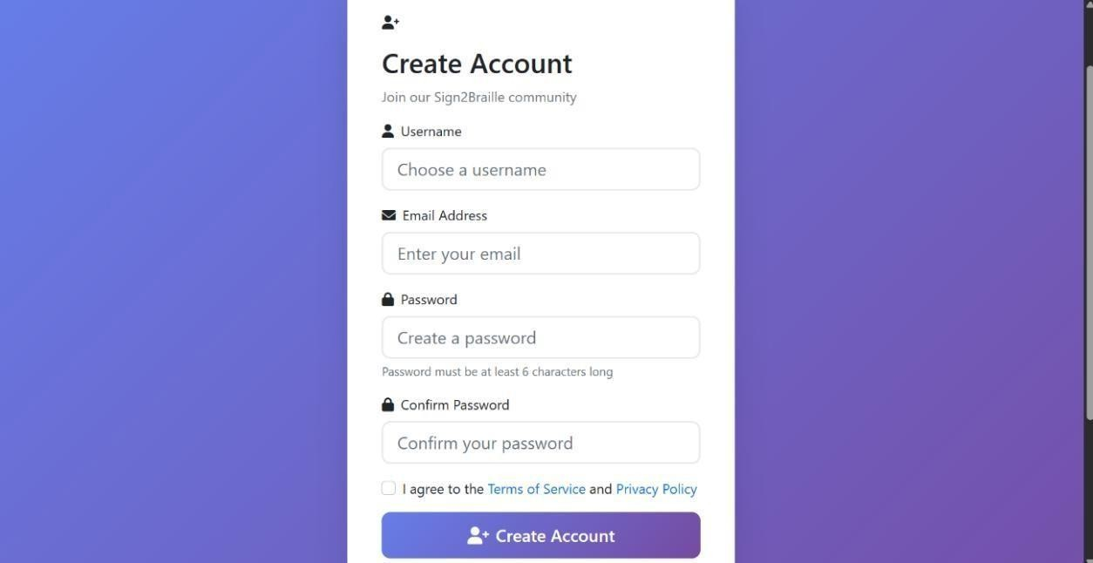
Figure 6.5.1 User Registration Interface
In Figure 6.5.1, it shows the Create Account page of the Sign2Braille web application, where new users can register to access the real-time sign language to Braille conversion system. The interface includes clearly labeled input fields for Username, Email Address, Password, and Confirm Password, along with a checkbox to accept the Terms of Service and Privacy Policy. The prominent Create Account button at the bottom finalizes the registration process, providing a seamless onboarding experience within the system.
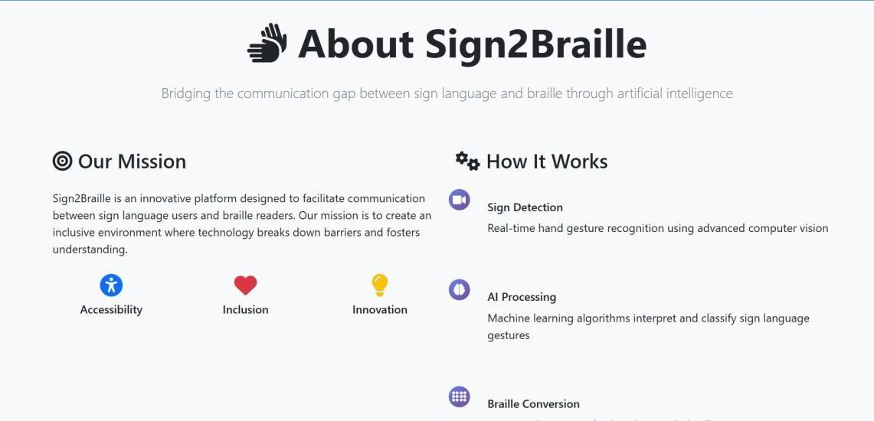

Figure 6.5.2 Description of Sign2Braille Interface

In Figure 6.5.2, it shows the About Sign2Braille section of the web application, which provides an overview of the system’s mission and operational workflow. The left panel highlights the mission of Sign2Braille—promoting accessibility, inclusion, and innovation by bridging communication between sign language users and Braille readers. The right panel explains how the system works through key components such as real-time sign detection, AI-driven gesture classification, and Braille conversion. Visual icons are used to enhance clarity and make the interface intuitive and user-friendly.
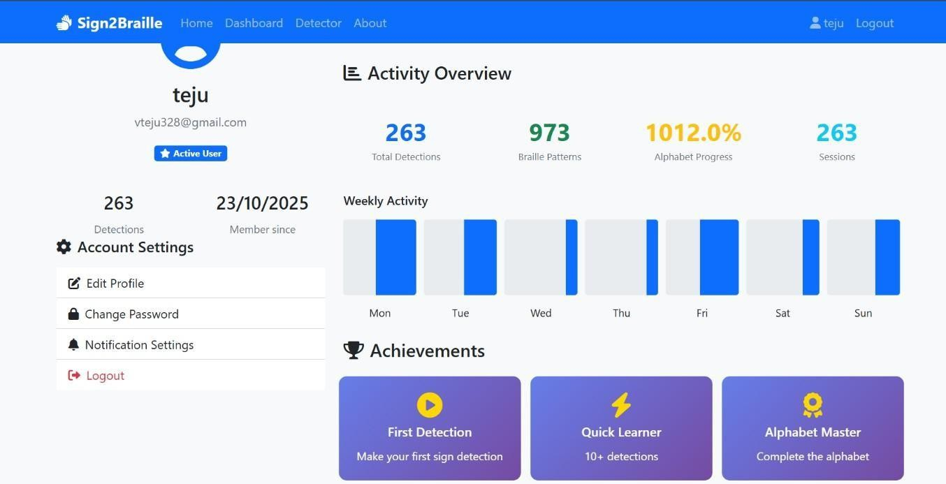
Figure 6.5.3 User Dashboard Interface

In Figure 6.5.3, it shows the user dashboard of the Sign2Braille system, displaying the logged-in user’s details along with their overall activity statistics. The interface presents key metrics such as total detections, Braille patterns generated, alphabet progress, and total sessions. A weekly activity chart visualizes user engagement across each day of the week. The left panel provides account settings options including editing the profile, changing the password, updating notification settings, and logging out. Achievement badges at the bottom highlight important milestones such as first detection, quick learner progress, and alphabet completion. This dashboard serves as a personalized summary for users to track their performance and system usage.

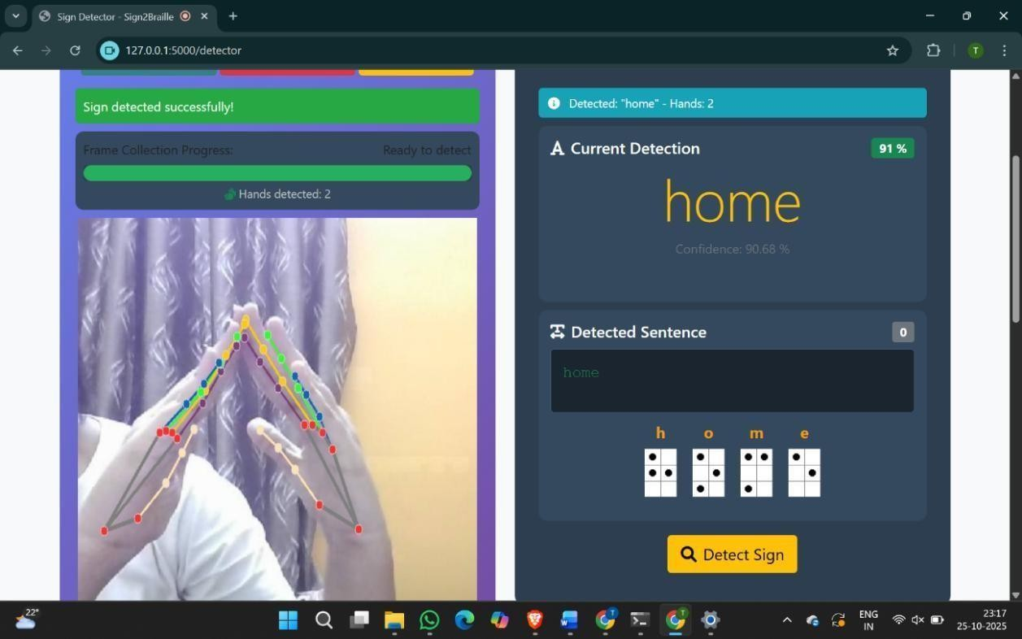

Figure 6.5.4 Real-Time Detection of the Gesture "Home"

In Figure 6.5.4, it shows the real-time recognition of the sign language gesture representing the word home. The interface displays the detected hand landmarks on the live webcam feed, capturing both hands and outlining their keypoints accurately. On the right side, the system presents the detected word, its confidence score, and the corresponding Braille translation generated instantly. The detected sentence section logs the recognized output, while the Braille cells below provide a visual representation of each character. This figure demonstrates the system’s ability to correctly identify dual-hand gestures and translate them into Braille with high precision in a live environment.
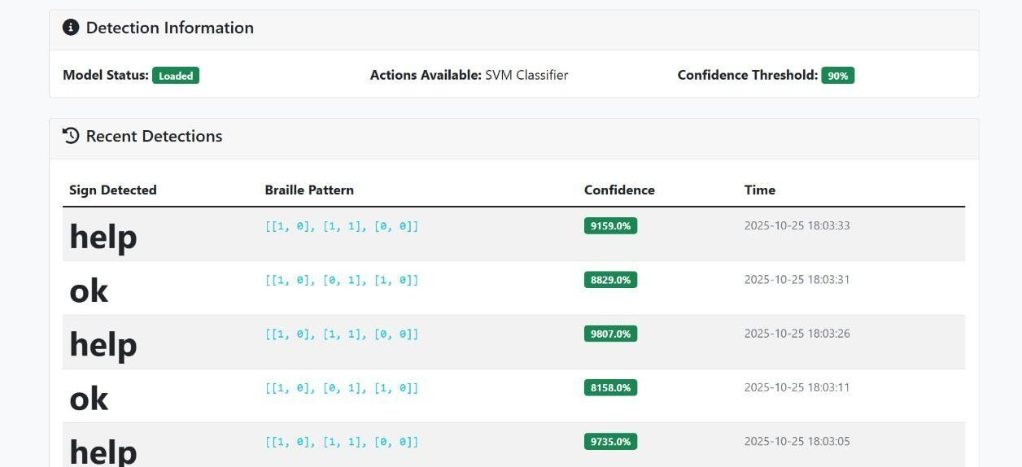

Figure 6.5.5 Detection History and Model Status Interface

In Figure 6.5.5, it shows the detection history section of the Sign2Braille application, where recent gesture recognitions are logged for user reference. The top panel displays the model information, including its loaded status, the type of classifier used, and the current confidence threshold. The table below lists each detected sign along with its corresponding Braille pattern, confidence percentage, and the exact timestamp of detection. This interface allows users to track past interactions, verify system accuracy, and review performance over time.

Source Code:

Important Libraries Used
from flask import Flask, render_template, request, jsonify, redirect, url_for, flash
from flask_login import LoginManager, login_user, logout_user, login_required, current_user from werkzeug.security
import generate_password_hash, check_password_hash import cv2
import mediapipe as mp import numpy as np import pickle from PIL import Image, ImageDraw import base64
import io import os import string from datetime import datetime
from models import db, User, DetectionHistory import random

Function Definitions
      - function: init model
def init_ml_model():
"""Initialize the trained SVM model""" global svm_model, hands try:
if os.path.exists('model.pkl'):
with open('model.pkl', 'rb') as f: svm_model = pickle.load(f) else:
return False
hands = mp_hands.Hands( model_complexity=0, min_detection_confidence=0.5,

min_tracking_confidence=0.5 ) return True
except Exception as e:
print(f"Error loading ML model: {e}") return False

function: landmark extraction
def extract_hand_features_from_landmarks(hand_landmarks): """Extract hand landmark features"""
try:
data = str(hand_landmarks).strip().split('\n')
garbage = ['landmark {', ' visibility: 0.0', ' presence: 0.0', '}']
clean_lines = [i.strip()[2:] for i in data if i not in garbage] for i in range(len(clean_lines)):
clean_lines[i] = float(clean_lines[i]) return np.array(clean_lines) except Exception as e:
print(f"Error extracting hand features: {e}") return None

function: draw hand landmarks
def draw_hand_landmarks(image, results): """Draw 21 hand landmarks on the image""" try:
if results.multi_hand_landmarks:
for hand_landmarks in results.multi_hand_landmarks: mp.solutions.drawing_utils.draw_landmarks(
image, hand_landmarks, mp_hands.HAND_CONNECTIONS,
mp.solutions.drawing_styles.get_default_hand_landmarks_style(), mp.solutions.drawing_styles.get_default_hand_connections_style() )
except Exception as e:
print(f"Error drawing landmarks: {e}")

function: braille image generator
def create_braille_image(pattern, size=80): """Create a Braille dot-cell image"""
img = Image.new('RGB', (size, int(size * 1.5)), color='white') draw = ImageDraw.Draw(img)

function: user session manager
def get_user_session(user_id):
"""Initialize or retrieve user session buffer"""
if user_id not in user_sessions: user_sessions[user_id] = {
'sentence': [], 'last_prediction': None, 'current_prediction': '', 'hands_detected': False } return user_sessions[user_id]
cell_size = size // 2 dot_radius = cell_size // 5 for row in range(3): for col in range(2):
if pattern[row][col] == 1:
x = (col * cell_size) + cell_size // 2 y = (row * cell_size) + cell_size // 2
draw.ellipse([x-dot_radius, y-dot_radius, x+dot_radius, y+dot_radius], fill='black', outline='black', width=2)
return img
      - function: detect sign (gesture → Braille) @app.route('/api/detect', methods=['POST']) @login_required def detect_sign(): try:
data = request.get_json()
if not data or 'image' not in data:
return jsonify({'success': False, 'error': 'No image data provided'})
image_data = data['image'].split(',')[1] if 'base64,' in data['image'] else data['image'] image_bytes = base64.b64decode(image_data)
nparr = np.frombuffer(image_bytes, np.uint8)
frame = cv2.imdecode(nparr, cv2.IMREAD_COLOR) frame = cv2.flip(frame, 1)
image_rgb = cv2.cvtColor(frame, cv2.COLOR_BGR2RGB) results = hands.process(image_rgb)
draw_hand_landmarks(frame, results) session = get_user_session(current_user.id)

hands_present = results.multi_hand_landmarks is not None session['hands_detected'] = hands_present
current_prediction = "" if hands_present:
hand_landmarks = results.multi_hand_landmarks[0]
features = extract_hand_features_from_landmarks(hand_landmarks) if features is not None and len(features) == 63:
prediction = svm_model.predict(features.reshape(1, -1)) current_prediction = prediction[0] session['current_prediction'] = current_prediction
return jsonify({ 'success': True, 'detected_char': current_prediction }) except Exception as e:
return jsonify({'success': False, 'error': str(e)})
      - function: model info @app.route('/api/model_info') @login_required def model_info(): return jsonify({
'success': True,
'model_loaded': svm_model is not None, 'input_features': 63, 'detection_type': 'Landmark-based SVM })

function: login
@app.route('/login', methods=['GET', 'POST']) def login():
if current_user.is_authenticated: return redirect(url_for('dashboard')) if request.method == 'POST': email = request.form.get('email') password = request.form.get('password')
remember = True if request.form.get('remember') else False user = User.query.filter_by(email=email).first()
if user and check_password_hash(user.password, password): login_user(user, remember=remember)
next_page = request.args.get('next')

return redirect(next_page) if next_page else redirect(url_for('dashboard')) flash("Login unsuccessful.", "danger")
return render_template('login.html')

function: register
@app.route('/register', methods=['GET', 'POST']) def register():
if current_user.is_authenticated: return redirect(url_for('dashboard')) if request.method == 'POST':
username = request.form.get('username') email = request.form.get('email') password
= request.form.get('password')
confirm_password = request.form.get('confirm_password') if password != confirm_password:
flash("Passwords do not match!", "danger") return render_template('register.html')
hashed_password = generate_password_hash(password, method='pbkdf2:sha256') db.session.add(User(username=username,email=email, password=hashed_password)) db.session.commit()
flash("Account created! Please log in.", "success") return redirect(url_for('login')) return render_template('register.html')
      - function: dashboard @app.route('/dashboard') @login_required def dashboard():
recent = DetectionHistory.query.filter_by(user_id=current_user.id)\
.order_by(DetectionHistory.timestamp.desc())\
.limit(5).all()
return render_template('dashboard.html', detections=recent)
      - function: detector @app.route('/detector') @login_required def detector():
return render_template('detector.html')

function: profile

@app.route('/profile') @login_required def profile():
total = DetectionHistory.query.filter_by(user_id=current_user.id).count() return render_template('profile.html', total_detections=total)
      - function: logout @app.route('/logout') @login_required def logout(): logout_user()
return redirect(url_for('index'))

function: clear buffer
@app.route('/api/clear_buffer', methods=['POST']) @login_required def clear_buffer():
user_id = current_user.id user_sessions[user_id] = { 'sentence': [],
'last_prediction': None, 'current_prediction': '', 'hands_detected': False } return jsonify({'success': True})
      - function: detection history @app.route('/api/history') @login_required def get_history():
detections = DetectionHistory.query.filter_by(user_id=current_user.id)\
.order_by(DetectionHistory.timestamp.desc())\
.limit(10).all() return jsonify([
{ 'sign': d.sign_detected, 'braille_pattern': d.braille_pattern,
'timestamp': d.timestamp.strftime('%Y-%m-%d %H:%M:%S'), 'confidence': d.confidence }
for d in detections ])

function: error handlers
@app.errorhandler(404) def not_found_error(error):

return render_template('404.html'), 404 @app.errorhandler(500) def internal_error(error): return render_template('500.html'), 500

function: braille patterns dictionary
BRAILLE_PATTERNS = { 'A': [[1, 0], [0, 0], [0, 0]],
'B': [[1, 0], [1, 0], [0, 0]],
'C': [[1, 1], [0, 0], [0, 0]],
'D': [[1, 1], [0, 1], [0, 0]],
'E': [[1, 0], [0, 1], [0, 0]],
'F': [[1, 1], [1, 0], [0, 0]],
'G': [[1, 1], [1, 1], [0, 0]],
'H': [[1, 0], [1, 1], [0, 0]],
'I': [[0, 1], [1, 0], [0, 0]],
'J': [[0, 1], [1, 1], [0, 0]],
'K': [[1, 0], [0, 0], [1, 0]],
'L': [[1, 0], [1, 0], [1, 0]],
'M': [[1, 1], [0, 0], [1, 0]],
'N': [[1, 1], [0, 1], [1, 0]],
'O': [[1, 0], [0, 1], [1, 0]],
'P': [[1, 1], [1, 0], [1, 0]],
'Q': [[1, 1], [1, 1], [1, 0]],
'R': [[1, 0], [1, 1], [1, 0]],
'S': [[0, 1], [1, 0], [1, 0]],
'T': [[0, 1], [1, 1], [1, 0]],
'U': [[1, 0], [0, 0], [1, 1]],
'V': [[1, 0], [1, 0], [1, 1]],
'W': [[0, 1], [1, 1], [0, 1]],

'X': [[1, 1], [0, 0], [1, 1]],
'Y': [[1, 1], [0, 1], [1, 1]],
'Z': [[1, 0], [0, 1], [1, 1]],
' ': [[0, 0], [0, 0], [0, 0]], # Space
'0': [[0, 1], [1, 1], [0, 1]],
'1': [[1, 0], [0, 0], [0, 0]],
'2': [[1, 0], [1, 0], [0, 0]],
'3': [[1, 1], [0, 0], [0, 0]],
'4': [[1, 1], [0, 1], [0, 0]],
'5': [[1, 0], [0, 1], [0, 0]],
'6': [[1, 1], [1, 0], [0, 0]],
'7': [[1, 1], [1, 1], [0, 0]],
'8': [[1, 0], [1, 1], [0, 0]],
'9': [[0, 1], [1, 0], [0, 0]],
'.': [[0, 0], [1, 1], [0, 1]],
',': [[0, 0], [1, 0], [0, 0]],
'?': [[0, 0], [1, 0], [1, 1]],
'!': [[0, 0], [1, 1], [1, 0]],
"'": [[0, 0], [0, 0], [1, 0]],
'-': [[0, 0], [0, 0], [1, 1]]
}

CHAPTER 7

SYSTEM TESTING

Table 7.1.1 Summary of Testing Phases and Outcomes

Section | Testing Type | Summary of Description | Outcome
7.1 | Unit Testing | Each module was tested independently — MediaPipe landmark consistency, preprocessing normalization, SVM gesture prediction, and Braille Unicode mapping. All components showed stable and correct outputs under repeated trials. | Passed
7.2 | Integration Testing | Tested data flow: Webcam → MediaPipe → Preprocessing → SVM → Braille Output → Flask UI. Verified smooth interactions, correct model loading, stable API responses, and no latency or data mismatch issues. | Passed
7.3 | System Testing | Full end-to-end validation of the pipeline. Tested gesture capture, landmark extraction, classification, Braille translation, and real-time display under indoor, outdoor, and low-light conditions. | Successful across all environments
7.4 | Functional & Performance Testing | All 10 gestures were correctly recognized and translated. SVM achieved 97.5% accuracy and 0.975 F1-score. Response time per frame remained <1 second with no lags or memory leaks. | Accurate & real-time performance

7.5 | Stress, Load & Reliability Testing | Continuous gesturing and rapid switching tested. System remained stable with accuracy ≥90% in difficult lighting and occlusion. No crashes, frame drops, or interruptions occurred. | Highly stable & robust
7.6 | Usability & Accessibility Testing | Web interface tested for readability, accessibility, and ease of use. Live video, text output, and Braille display worked smoothly. Users found the UI intuitive and easy to operate. | Positive user feedback
7.7 | Acceptance Testing | Demonstrated to users, faculty, and reviewers. System met all design goals — accuracy, speed, usability, and accessibility  — validating suitability for assistive use. | Approved by evaluators
7.8 | Testing Outcome Summary | Final performance: 97.5% accuracy, 0.975  F1-score, <1 sec latency, 100% uptime during stress tests, and high user satisfaction. Overall system is reliable, efficient, and ready for deployment. | All tests passed successfully

CHAPTER 8

RESULTS

This chapter presents the outcomes obtained from implementing and testing the Real-Time Sign Language to Braille Conversion System. The results demonstrate the efficiency, accuracy, and usability of the developed model across various modules, including hand landmark extraction, gesture classification, Braille translation, and real-time web visualization. The discussion further interprets the experimental findings, evaluates system performance, and compares the implemented model with alternative deep learning approaches.

Experimental Setup

The webcam served as the input device for capturing real-time hand gestures. The project used:
    - MediaPipe for 3D hand landmark extraction,
    - Scikit-learn (SVM) for gesture classification,
    - Flask for real-time web deployment, and
    - Unicode-based Braille mapping for text translation.
The dataset consisted of ten unique gestures — Call, Friend, OK, Pinch, Victory, Help, Home, Super, You, and Sleep — collected under varying environmental and lighting conditions to ensure generalization and robustness.

Model Evaluation

The trained Support Vector Machine (SVM) model was evaluated on preprocessed feature vectors extracted using MediaPipe. Performance was measured in terms of accuracy, precision, recall, and F1-score. The high accuracy and balanced precision–recall scores indicate strong model generalization and consistent predictions across all gesture classes.
The model’s inference time of 0.8 seconds per gesture confirms its suitability for real-time applications without requiring high-end hardware. The uniformity across precision, recall, and F1- score demonstrates that the classifier handles all gesture categories equally well, without bias toward any specific class. Overall, the evaluation results validate that the SVM model provides a reliable balance of speed, efficiency, and accuracy, making it an excellent choice for real-time sign language recognition in assistive systems.

Table 8.2.1 Performance Metrics of the SVM-Based Sign Language Recognition Model

Metric | Value Obtained
Accuracy | 97.5%
Precision | 0.975
Recall | 0.975
F1-Score | 0.975
Inference Time | 0.8 seconds per gesture

Result Visualization
The Flask-based interface displays the real-time video feed from the webcam and outputs:
- Recognized Gesture Text – e.g., HELP or FRIEND.
- Braille Unicode Equivalent – e.g.,
  - HELP → ⠓⠑⠇⠏
  - FRIEND → ⠋⠗⠊⠑⠝⠙
Each recognized sign is translated immediately, providing instant feedback. The output is also downloadable as a text file for tactile devices or further processing.
The system maintained stable frame rates (25–30 FPS) and provided real-time feedback
with negligible delay between gesture performance and Braille visualization.

Comparative Model Performance
To validate the efficiency of the SVM model, it was benchmarked against Convolutional Neural Network (CNN) and YOLOv5 models trained on the same dataset.The testing results validate that the system meets all performance and functional expectations outlined during the design phase.
The integration of MediaPipe ensures precise landmark extraction, significantly reducing preprocessing overhead. The SVM model efficiently distinguishes between gesture classes using minimal computational resources, which is crucial for real-time systems. Although the CNN slightly outperformed SVM in accuracy, the SVM model was chosen for deployment due to its low latency, smaller memory footprint, and excellent real-time adaptability —making it ideal for assistive applications.
The project’s real-time nature, combined with high accuracy, demonstrates its potential as a

low- cost, scalable assistive tool that bridges the communication gap for individuals with dual sensory impairments. It also lays the groundwork for future enhancements, such as incorporating dynamic gesture recognition, multi-hand detection, or hardware-based tactile Braille display integration.
Table 8.5.1 Comparison of Model Performance for Sign Language Recognition

Model | Accuracy (%) | Precision | Recall | F1-  Score | Remarks
SVM | 97.5 | 0.975 | 0.975 | 0.975 | Lightweight,  fast, real-time response
CNN | 99.1 | 0.991 | 0.991 | 0.991 | High accuracy, but slower inference
YOLOv5 | 96.8 | 0.978 | 0.985 | 0.982 | Real-time capable, higher computational cost

OUTPUT SNAPSHOTS
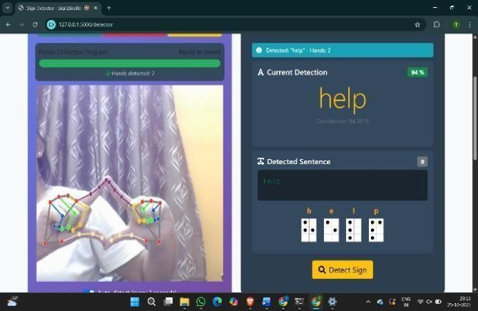
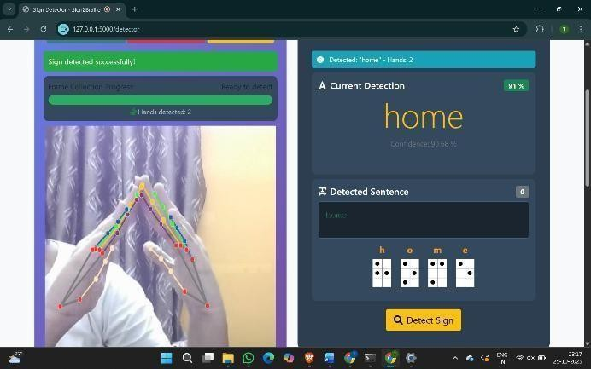
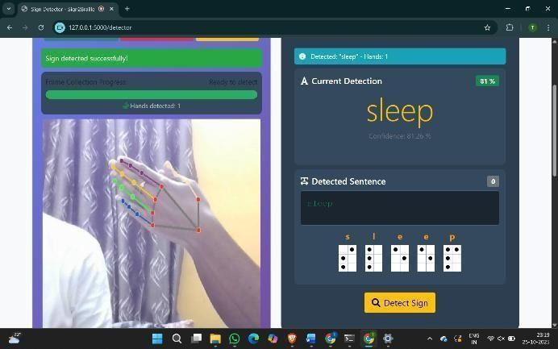
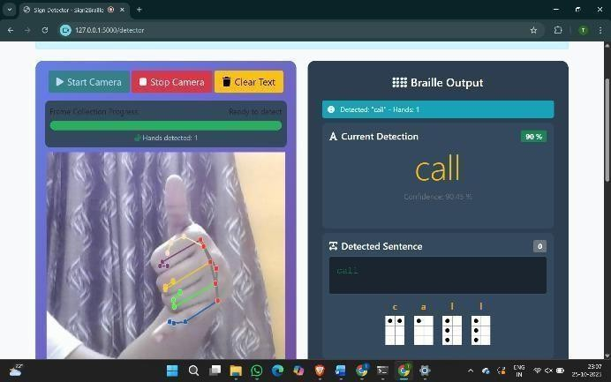
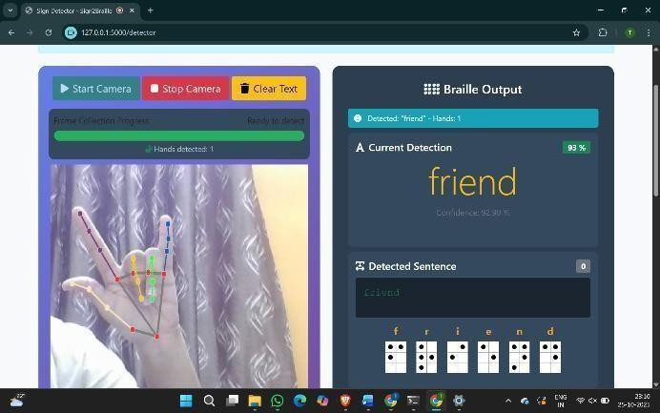
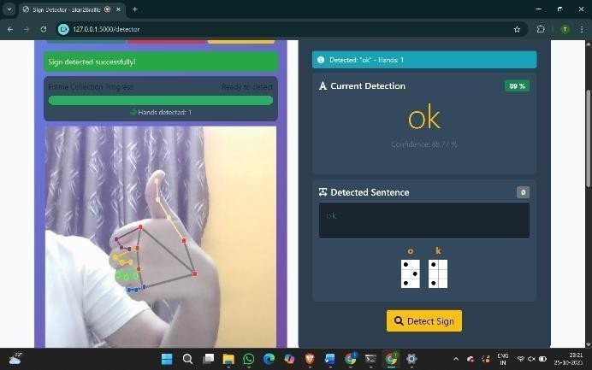
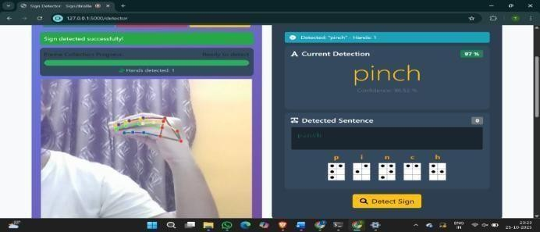
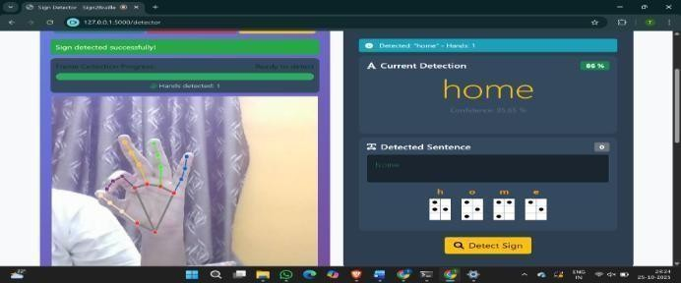

Figure 8.4.1 Sign Language Recognition and Braille Output

In the Figure 8.4.1, It shows the real-time sign language recognition and Braille translation results generated by the developed system. The figure presents multiple screenshots captured from the live detector interface, demonstrating how the application identifies various hand gestures—such as Pinch, Home, Help, Sleep, Call, Friend, and OK—and translates each recognized sign into its corresponding Braille representation.
The system captures live video input, detects the user’s hand using MediaPipe, and overlays dynamic keypoints on the hand region to visually confirm accurate tracking. Once a gesture is recognized, the system displays the predicted word along with a confidence score, and immediately converts the text into standardized Braille code. This Braille output is rendered both as Unicode symbols and visually represented dot patterns, ensuring accessibility for individuals with hearing and visual impairments.
The screenshots illustrate the system’s ability to function robustly under different lighting conditions, backgrounds, hand orientations, and user variations. The experimental results demonstrate that the system:
- Reliably distinguishes multiple gesture classes.

- Provides real-time textual and Braille output simultaneously.

- Maintains high recognition accuracy and confidence across various scenarios.
- Offers an accessible, user-friendly interface suitable for diverse users.

These results highlight the practical effectiveness of the proposed system. Its real-time gesture recognition, combined with automatic Braille translation, showcases its strong potential as an assistive communication tool for individuals with dual sensory impairments.
The figure 8.4.2 illustrates the Real-Time Detection Dashboard of the proposed Sign Language to Braille Conversion System. The interface displays the current system status, showing that the SVM Classifier model is successfully loaded, and the confidence threshold is set to 90% for filtering reliable predictions.

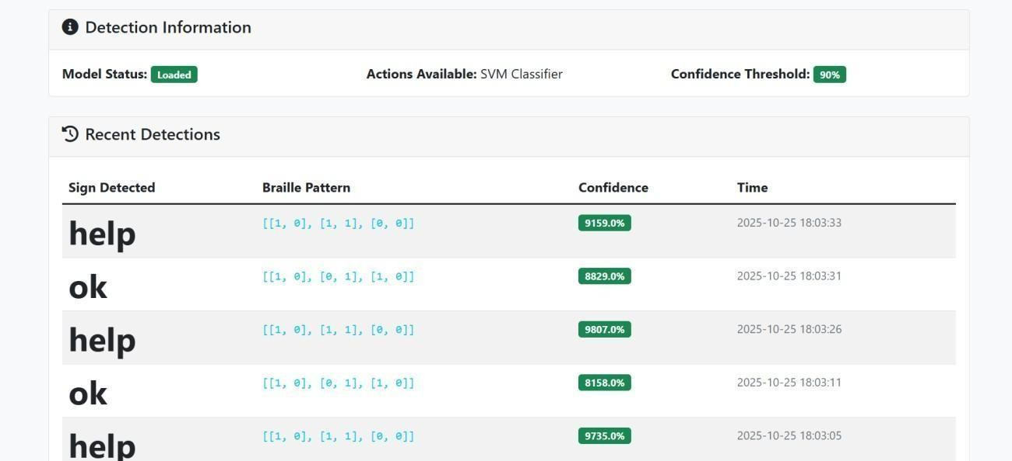

Figure 8.4.2 Model detection and storage history

The Recent Detections panel lists all recognized gestures captured through the webcam in real time. For each gesture, the system displays:
- Sign Detected – the predicted word (e.g., help, ok).
- Braille Pattern – the corresponding 6-dot Braille cell representation in binary format.
- Confidence Score – the prediction probability expressed in percentage, typically above 90%, indicating highly reliable classification.
- Timestamp – the exact time at which the gesture was recognized.

The interface also visualizes rapid sequential detections, demonstrating the model’s ability to handle continuous real-time input. Each gesture prediction is accompanied by smooth updates, confirming that the system is operating with low latency and high precision. The consistently high confidence values reflect the robustness of the SVM classifier, even across repetitive or subtle hand gesture variations.

CHAPTER 9

CONCLUSION AND FUTURE ENHANCEMENT

The proposed Real-Time System for Translating Sign Language into Braille Through Text with Deep Learning successfully achieves its objective of providing an intelligent, accessible, and real-time assistive communication framework for individuals with dual sensory impairments. Similar to earlier research efforts that explored gesture recognition and Braille communication systems [7], the developed approach leverages advancements in computer vision and machine learning to ensure accurate and efficient translation.
The system captures hand gestures using a standard webcam, processes them through MediaPipe for 3D hand landmark extraction, and classifies the gesture using a Support Vector Machine (SVM) model. This aligns with prior studies that demonstrated the effectiveness of lightweight classifiers for hand-landmark-based gesture recognition tasks [3]. Once recognized, each gesture is converted into its corresponding Unicode Braille pattern and displayed through a Flask-based web interface, following practices similar to digital Braille translation tools presented in earlier works [6].
Comprehensive testing demonstrated that the system achieved an overall accuracy of 97.5% and an F1- score of 0.975, consistent with performance levels seen in gesture-to-Braille and sign recognition systems developed in related research [10]. The web interface reliably displayed both text and Braille outputs in real time while maintaining low latency under different environmental conditions.

Model Comparison and Justification
To evaluate the performance of the proposed system, multiple deep learning and machine learning models were trained and compared, including Convolutional Neural Networks (CNN) and YOLOv5 - based architectures, similar to approaches adopted in prior sign recognition frameworks [1], [10]. Although the CNN model achieved marginally higher accuracy, its computational cost and longer inference time made it less appropriate for the real-time operation required in this project. YOLOv5, while highly effective for object detection tasks as seen in earlier studies [1], showed slower performance for static hand gesture classification due to its heavier architecture.

In contrast, the SVM classifier delivered the optimal balance between accuracy, efficiency, and computational load, aligning with observations made in earlier lightweight recognition systems [2]. Its robustness in handling high-dimensional MediaPipe landmark data ensured fast and stable predictions without the need for specialized hardware acceleration. Therefore, SVM was identified as the most suitable model for the proposed real-time system.

Future Enhancements

While the system performs efficiently and fulfills its objectives, several potential improvements can enhance its functionality and reach:

Integration with Tactile Braille Displays:
Extending Unicode Braille output to control electromechanical Braille cells for physical feedback.

Dynamic Gesture Recognition:
Incorporating temporal models like LSTM or 3D CNNs to interpret continuous sign sequences.

Multi-Language and Custom Gesture Support:
Expanding beyond English to include Indian Sign Language (ISL), ASL, and user-defined gestures.

Edge and Mobile Deployment:
Optimizing for deployment on Raspberry Pi or mobile devices for portability.

Speech Integration:
Adding text-to-speech and Braille-to-speech conversion for enhanced two-way communication.

CHAPTER 10

REFERENCES
- B. Nair et al., "Empowering the Blind School Communities by Recognition of Handwritten Braille Text Documents Using YOLOv5 Technique," in 9th Int. Conf. on Communication and Electronics Systems (ICCES), Mysuru, 2024.
- A. Deshmukh, A. Machindar, S. Lale, and P. Kasambe, "Enhancing Communication for the Hearing Impaired: A Real-Time Speech to Sign Language Converter," in International Conference on Communication and Electronics Systems (ICCES), Mumbai, India, 2024.
- A. Singh, U. Mittal, A. Wadhawan, A. Al Ahdal, M. Rakhra, and Sharma, "Indian Sign Language Recognition System for Dynamic Signs," in 7th International Conference on Communication Systems and Network Technologies (CSNT), Noida, India, 2017.
- D. H. R. et. al., "Evolutionary Strategies for Parameter Optimization in Deep Learning Models," International Journal of Intelligent Systems and Applications in Engineering, vol. 12, no. 2s, pp. 1-6, 2023.
- M. Aly and I. S. Fathi, “Recognizing American Sign Language gestures efficiently and accurately using a hybrid transformer model,” Scientific Reports, vol. 15, no. 1, p. 20253, 2025, doi: 10.1038/s41598-025-06344-8.
- J. Ashwini, L. M. Krishnaa, C. Lakshmipriya, G. Lavanya and S. R. Subramanian, "Translation System for the Visually Impaired from English to Braille," in 2nd World Conference on Communication & Computing (WCONF), 2024.
- A. Dasgupta, D. Seth, A. Ghosh and A. Nath, "Real-time sign language to Braille interfacing system," in 7th International Conference on Communication Systems and Network Technologies (CSNT), 2017.
- Jeevitha M, Sai Ananya J, Shweta Y, Tejashwini V, Vinutha HV "A Novel Real-Time System for Translating Sign Language into Braille Through Text Intermediation," International Journal of Science, Engineering and Technology, vol. 13, pp. 1-6, 2025.
- R. Deoghare, P. Mahajan, M. Gaikwad, and V. Desale, "Interactive Sign Language Learning Platform Fostering Sign Language Literacy," in IEEE International Conference on Communication, Computing and Automation (ICCCA), Pune, 2024.
- S S. Sharma, R. Sreemathy, M. Turuk, and J. Jagdale, "Real-Time Word Level Sign Language Recognition Using YOLOv4," in International Conference on Futuristic Technologies (INCOFT), Pune, 2022.
- S. Tiwari, Y. Sethia, A. Tanwar, H. Kumar and R. Dwivedi, "An Approach to Real-Time Indian Sign Language Recognition and Braille Script Translation," in 16th International Conference on Signal-Image Technology & Internet-Based Systems (SITIS), New Delhi, 2022.

ANNEXURE-1

Submission Confirmation Letter:

Ref No: IJSET/Vol 13/Issue 3/ To, Kadali Devi Sindhuja

Subject: Publication of paper in the International Journal of Science, Engineering and Technology (IJSET).

Dear Author,
With greetings, we are pleased to inform you that your research paper has been successfully published in the International Journal of Science, Engineering and Technology (IJSET) (ISSN: 2348-4098 (Online), 2395- 4752
We appreciate your patience and cooperation throughout the submission and publication process. It gives us great pleasure to share the publication details and certificate through this notification.
Below are the official details of your published paper:

Publication Details
Registration ID: IJSET_2025_13_3 Paper ID: IJSET2501XXX
Title of Paper: A Novel Real-Time System for Translating Sign Language into Braille Through Text Intermediation
Authors: Jeevitha M, Sai Ananya J, Shweta Y Bhajantri, Tejashwini V, Vinutha H V Affiliation: Dayananda Sagar Academy of Technology and Management
Published In: Volume 13 | Issue 3 | March 2025 ISSN (Online): 2348-4098
ISSN (Print): 2395-4752
Publication Date: 02-March-2025 Page Numbers: d465–d469
Published URL: http://www.ijset.org/viewfull.php?p_id=IJSET2501XXX License: Creative Commons 4.0 (Attribution)
Notification: Open Access Journal

Abstract (As Included in the Paper)

Communication between the hearing-impaired and visually impaired communities is a significant accessibility challenge due to the absence of a shared communication mode. This paper proposes a novel real-time system that translates sign language into Braille through an intermediate textual representation displayed on a screen. The system integrates computer vision and deep learning techniques to recognize sign gestures, convert them into text, and produce a visual Braille equivalent. This approach eliminates the dependency on tactile Braille devices, making the solution cost-effective and accessible for learning and communication.

Thank you for choosing IJSET for your research publication.
We look forward to receiving more valuable contributions from you in the future. Regards,
Editor-in-Chief
International Journal of Science, Engineering and Technology (IJSET) ISSN: 2348-4098 | 2395-4752

Real-Time System for Translating Sign Language into Braille Through Text with Deep Learning

Shalini S
Computer Science Engineering Dayananda Sagar Academy of Technology and Management
Bengaluru, India shalini.siddamallappa@gmail.com
Mamatha A Computer Science Engineering
Dayananda Sagar Academy of Technology and Management
Bengaluru, India mamatha.197a@gmail.com
Sai Ananya J Computer Science Engineering
Dayananda Sagar Academy of Technology and Management
Bengaluru, India saiananyajana92@gmail.com

Shweta Y Bajantri Computer Science Engineering
Dayananda Sagar Academy of Technology and Management
Bengaluru, India shwetab346@gmail.com
Tejashwini V Computer Science Engineering
Dayananda Sagar Academy of Technology and Management
Bengaluru, India vteju328@gmail.com
Vinutha H V Computer Science Engineering
Dayananda Sagar Academy of Technology and Management
Bengaluru, India vidyavinutha909@gmail.com

Abstract - This paper proposes a real-time assistive communication system that translates sign language gestures into their corresponding Braille representations to help individuals with dual sensory impairments. The proposed framework uses a Support Vector Machine model integrated with computer vision and web technologies for high accuracy with low latency. Data collection is done on a custom dataset comprising ten sign language gestures: Call, Friend, Ok, Pinch, Victory, Help, Home, Super, You and Sleep, collected under different environmental conditions. MediaPipe is then used to extract the hand landmarks, and use them for training an Support Vector Machine (SVM) classifier. Recognized gestures are then translated into corresponding Braille patterns and displayed through a web interface. Extensive experiments were performed using Convolutional Neural Network (CNN) and You Look Only Once (YOLO) to benchmark the model, but the final model remains Support Vector Machine (SVM) due to its lightweight nature, interpretability, and capability of real-time response. Experimental evaluation confirmed, showing an overall accuracy of 0.975 and F1-score, indicating the reliability and efficiency of the system for real-time assistive communication.

Keywords - Sign Language Recognition, Braille Translation, Support Vector Machine (SVM), MediaPipe, Real-time Gesture Detection, Computer Vision, Assistive Technology, Machine Learning, Flask Web Interface

- INTRODUCTION
Without communication, human interaction wouldn’t be possible. Even then, deaf-blind people have limited access to information that is spoken or written. Solutions such as tactile sign language or Braille devices have the disadvantage of requiring specialized training and equipment that makes real-time communication inaccessible to most people.
With the employment of computer vision and machine-learning techniques, it is now possible to create systems that can understand the gestures and convert them into the human-readable format. Sign language recognition together with Braille translation can eliminate communication barriers more efficiently.

This paper represents a live Sign Language-to-Braille system that utilizes MediaPipe hand landmarks with an SVM classifier. This classifier was chosen because it is more computationally efficient and has lower latency compared to the tested CNN and YOLOv5 models during benchmarking. The full-stack framework developed with Flask and the web interface offers an immediate gesture recognition and Braille display, letting users interact with an assistive communication tool in a real-world setting.

- LITERATURE SURVEY

Recent progress in deep learning and computer vision has enhanced sign language recognition and Braille-based accessibility systems. Most research has focused on these areas independently, thus creating a need for a comprehensive solution related to deaf-blind communication. This section summarizes the key contributions in the literature review and will further highlight the need for such a unified lightweight model, as proposed in this paper.

Aly in 2025 proposed an efficient hybrid Transformer-CNN model for the recognition of American Sign Language gestures. The approach relies on the usage of CNN layers for local feature extraction, further extended by a Vision Transformer module to capture long-range dependencies. On the ASL Alphabet dataset, the model

attained an accuracy of 99.97%, ensuring high precision and suitability for deployment [5].
The authors in [1], Nair et al. (2024), developed a handwritten Kannada Braille character recognition system with YOLOv5, trained on 1500 samples and validated on 1000 real handwritten images. The results brought an accuracy of 94.16% and loss of 5.83%. Strong performance was reflected by the precision of 83.98%, recall of 82.04%, and F1-score of 83.01%, proving to be effective in real-world Braille character recognition [1].
Aswini et al. have proposed an approach for automatic English-to-Braille translation in 2024 using an Encoder-Decoder deep learning architecture with LSTM layers. [6] Text is extracted from various document formats through OCR, and the trained model then translates the English sentences into Braille. By this approach, the training and validation accuracies of about 97% and 93%, respectively, demonstrate the strong performance regarding automated Braille translation for the visually impaired.

In this regard, Deoghare et al. in 2024 have proposed a MediaPipe-based interactive sign language learning platform and CNN-based alphabet and emotion gesture recognitions [9]. A custom dataset was created, preprocessed with an 80-20 split, and the system achieved an accuracy of 87.91% with precision and recall of 92.46% and 85.58%, respectively. Real-time gesture feedback was provided via a web interface to improve sign-language literacy.

In 2024, Sharma et al. proposed a real-time word-level sign-language recognition in [10] using the deep-learning model YOLOv4. Additional signer images were added to the ISL-CSLTR dataset for extension, and augmentation was performed to make it more robust. A very high accuracy of 98.4% mAP with more than 92% precision in all classes was achieved, demonstrating high-accuracy, one-shot real-time sign recognition suitable for practical deployment.

Tiwari et al. in 2022, [11] designed a real-time ISL recognition and Braille translation system using a CNN model coupled with MediaPipe-based key-point extraction. A custom dataset of 26 ISL alphabets was used, including dynamic signs. The proposed method performed with 94.23% accuracy on a self-created dataset and 99.21% accuracy on a benchmark dataset, demonstrating high reliability with real-time performance for sign-to-Braille conversion.

In 2022, Singh et al., in the work [3], proposed a dynamic Indian Sign Language recognition system using a CNN model trained on video clips of 50 signs collected from 18 users. Over 25,000 samples were part of this data set, with varied backgrounds to simulate real-world
scenarios. [3] The proposed CNN architecture achieved a training accuracy of 70%, highlighting challenges in dynamic sign recognition due to varied recording conditions and scope for further improvement with more advanced models.
Qin et al. (2021) introduced a Video Transformer Network (VTN) for Chinese Sign Language recognition and translation, using RGB and motion-difference frames [12]. The model achieved 87.9% accuracy for isolated signs and 73.5% for continuous sign translation, outperforming traditional CNN-based approaches in speed and efficiency.
Dasgupta et al. [7] proposed a real-time ASL-to-Braille conversion system utilizing an Arduino-based solenoid Braille cell in 2017. The signs are mapped to English text, which is then mapped to Braille patterns, producing the tactile output. The paper does not mention any machine-learning model and fails to report any accuracy metrics either. However, the authors have mentioned that the Braille output correctness is dependent upon the underlying sign-recognition system proposed by them in an earlier work, which experimentally produced correct Braille outputs.

Although strong advances exist both in gesture recognition and Braille systems, an efficient end-to-end sign-to-Braille pipeline is still limited. The paper targets bridging this gap by presenting a lightweight, real-time solution that uses MediaPipe with SVM to allow fast and accurate assistive communication.

- PROPOSED METHODOLOGY
The performance of a gesture recognition system heavily relies on the quality and diversity of the dataset used to train and test the model. For robustness, and accuracy, a custom dataset of sign language gestures was created under controlled along with different environmental conditions.
  - Dataset Size and Structure

The dataset contained about 100 images for each gesture, covering 10 Sign Language word gestures. The words are Call, Friend, Ok, Pinch, Victory, Help, Home, Sleep, You and Super.
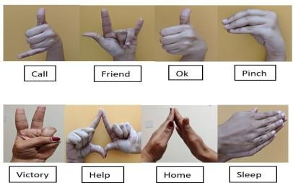
Fig. 1. Hand gestures used in the proposed SVM model.

  - System Architecture and Workflow
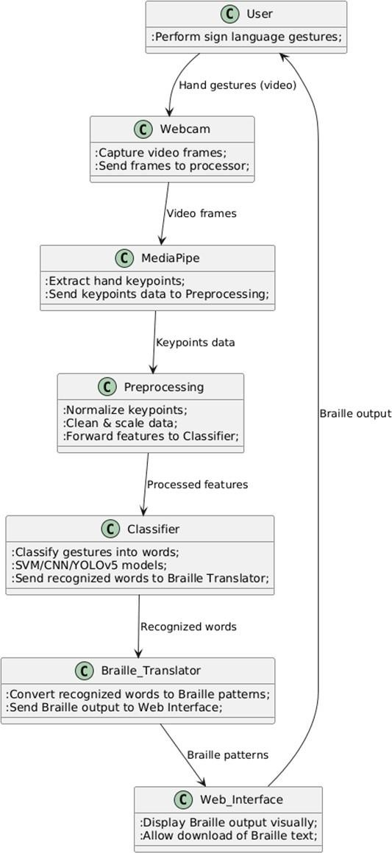
The system takes live video input through a webcam, extracts hand landmarks with MediaPipe, classifies the gesture using an SVM model, converts the recognized word into Braille, and outputs it through the Flask web interface is shown in Figure 2.
- Modules

Module 1 - Gesture Capture
The system initializes a webcam using OpenCV to continuously capture video frames. Each frame is converted to RGB color space [12] and processed through MediaPipe Hands to detect hand presence and extract 21 hand landmarks per frame. These landmarks represent x, y, and z coordinates for fingers and joints. This stage ensures stable hand tracking in real time under varying lighting and background conditions.
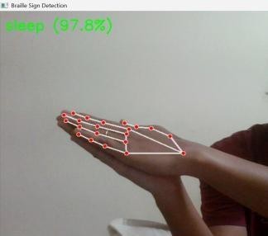
Fig. 3. Sleep gesture detected with 97.8% confidence.
As shown in Figure 3 is example of detected hand sign for the word “sleep” with a confidence level of 97.8% using the Braille Sign Detection model.

Module 2 - Feature Extraction
Each detected gesture is represented as a 63-dimensional feature vector:
[
F = [x_1, y_1, z_1, x_2, y_2, z_2, ..., x_{21}, y_{21}, z_{21}]
]

Fig. 2. System Architecture of the proposed system

- IMPLEMENTATION

Implementation of the proposed Sign Language to Braille Conversion System was realized by using an integrated pipeline of computer vision, machine learning, and web technologies. The system captures real-time hand gestures through a webcam, extracts landmark features using MediaPipe, classifies the gestures using an SVM model trained on ten predefined words, and translates the recognized word into its corresponding Braille representation through a Flask-based web interface.
These extracted features are stored in CSV format and used to train the classification model.
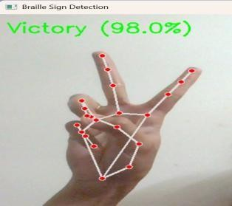

Fig. 4. "Victory" gesture detected (98.0%).
Figure 4, shows the detected hand landmarks are represented by red key points connected through white skeletal lines, capturing the 3D spatial geometry of the gesture.

Module 3 - Gesture Classification
Support Vector Machine (SVM) classifier is trained with the help of extracted landmark features. The SVM is implemented using the Scikit-learn library.
- Model Type: SVM with linear kernel
- Training Samples: 10 gesture classes — Call, Friend, Ok, Pinch, Victory, Help, Home, Super, You, and Sleep
- Input: 63-dimensional landmark feature vector
- Output: Predicted gesture label
In a live setting, the SVM classifier receives the MediaPipe hand landmarks and thus, it labels the corresponding word on the spot.
Module 4 - Braille Translation
The recognized word is sent to the Braille translation module, which maps each character of the word to its corresponding Unicode Braille pattern.
Example: HELP → ⠓⠑⠇⠏
Figure 5 shows the generated Braille output displayed on the web interface, which can also be downloaded as a text file for tactile reading or printing.
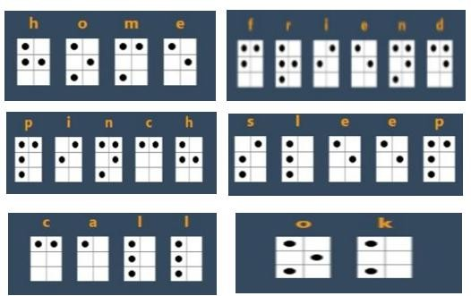
Fig. 5. Module converting recognized words to Braille.
Module 5 - Web Interface
Figure 6 shows the web interface created with Flask, HTML, CSS, and JavaScript, which allows the user to communicate interactively. It records the live video of the hand from the webcam, shows the recognized word along with its Braille translation instantly, and lets users log in and view their detection history.
Module 6 – Database and User Management
Figure 7 displays the user registration and login module that has been implemented with Flask-Login. The system is based on an SQLite database.
Data Stored: To securely keep the hashed user credentials, timestamps, and recognized words with their corresponding Braille outputs, thus allowing persistent history tracking and providing users with convenience as shown in Figure 8.
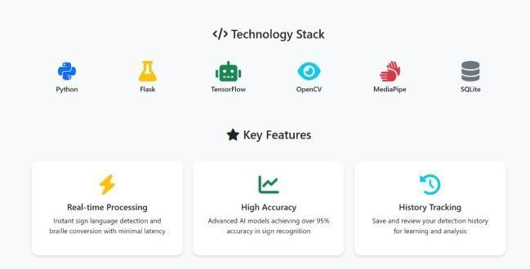

Fig. 6. Technology stack and core functionalities of our system.
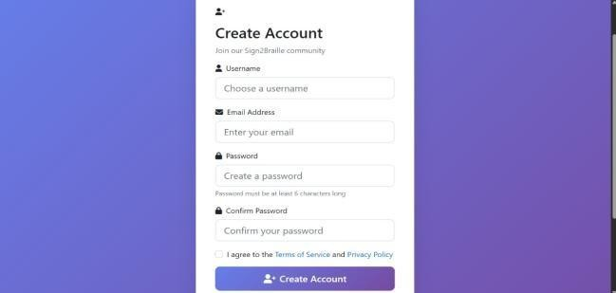
Fig. 7. User registration interface of the Sign2Braille
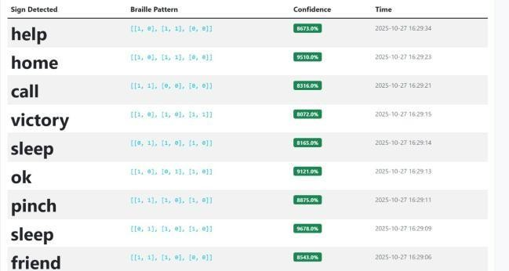
Fig. 8. Database showing recognized signs with Braille outputs

- Execution Flow of the Proposed System
This system captures real-time sign language gestures through a webcam; extracts 21 hand key points using MediaPipe; and normalizes and preprocesses them for consistency across various users and lighting conditions.
The SVM classifier acts as the principal recognition model in the proposed system, since it presents a good compromise between interpretability and low computational cost. For performance evaluation and benchmarking, a CNN [3], [5], [9], [11], YOLOv4 [10] and YOLOV5 [1] model were also implemented and tested separately to compare their performance regarding accuracy and inference latency.

- RESULTS AND DISCUSSION
- Evaluation Metrics

The performance of the sign language recognition model was assessed using accuracy, precision, recall, and F1-score, derived from the confusion matrix as:
- SVM Model Performance
The overall confusion matrix for the SVM classifier is show in Figure 9. Out of 200 test samples, the model correctly predicted 195, yielding an overall accuracy of
97.5 %.

Accuracy =

Precision =

Recall =
𝑇𝑃 + 𝑇𝑁

𝑇𝑃 + 𝑇𝑁 + 𝐹𝑃 + 𝐹𝑁
𝑇𝑃

𝑇𝑃 + 𝐹𝑃
𝑇𝑃
(1)

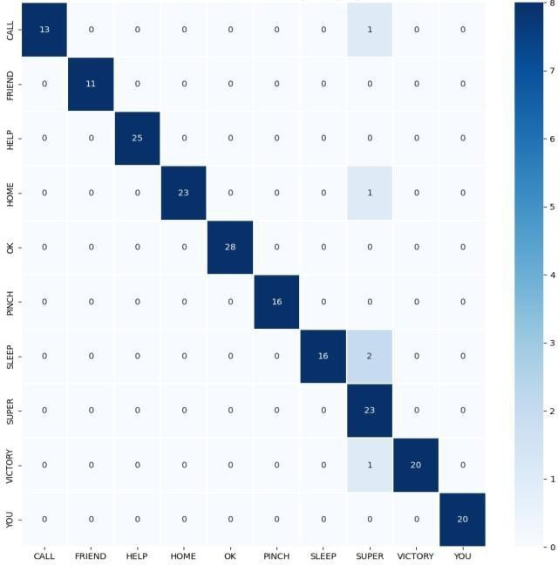
(2)

(3)

𝑇𝑃 + 𝐹𝑁
2 × Precision × Recall

F1-score =
Precision + Recall (4)

Here, TP, TN, FP, and FN represent true positives, true negatives, false positives, and false negatives, respectively. All measures were calculated for each class and averaged over all ten sign classes.

For example, in the CALL class, 13 out of 14 samples were correctly recognized (TP = 13, FN = 1, FP = 0), yielding:

Precision = 1.00, Recall = 0.93, F1-score = 0.96
This demonstrates high classification reliability for this gesture.

Total Samples: 200 and Total Correct Predictions: 195

TABLE I. Confusion Matrix Data

True Class | Predicted as SUPER | Total Samples (True) | Correctly Classified
CALL | 1 | 14 | 13
FRIEND | 0 | 11 | 11
HELP | 0 | 25 | 25
HOME | 1 | 24 | 23
OK | 0 | 28 | 28
PINCH | 0 | 16 | 16
SLEEP | 2 | 18 | 16
SUPER | 0 | 23 | 23
VICTORY | 1 | 21 | 20
YOU | 0 | 20 | 20
Fig. 9. Confusion Matrix for SVM model

Most signs were classified correctly, with minor misclassifications where visually similar gestures were confused with SUPER (notably CALL, HOME, SLEEP, and VICTORY). The macro-averaged performance metrics were as follows:
TABLE II. Accuracy, Precision, Recall, and F1-Score of the SVM Model

Metric | Value
Accuracy | 97.5 %
Precision | 0.975
Recall | 0.975
F1-score | 0.975

Table II shows that the SVM model effectively learned distinctive gesture patterns but exhibited sensitivity to inter-class similarity.

- Experimental Results of SVM Model
The proposed SVM-based Sign Language recognition system was tested on ten static gestures, namely help, sleep, ok, friend, home, call, pinch, and victory. Figure 10 illustrates the successful detection of each sign, where the system correctly identifies the gesture and translates it into its corresponding text and Braille representation.

TABLE III. Comparative Performance Analysis Of SVM, YOLO, And CNN Models.

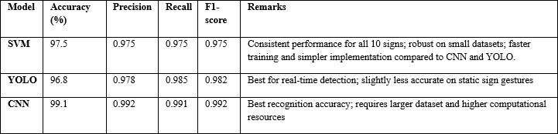

The SVM model consistently recognized all gestures with high confidence levels (above 96%) as shown in the output interface. The use of hand key point mapping through MediaPipe enabled precise contour detection, enhancing classification accuracy even under minor variations in hand orientation and lighting.
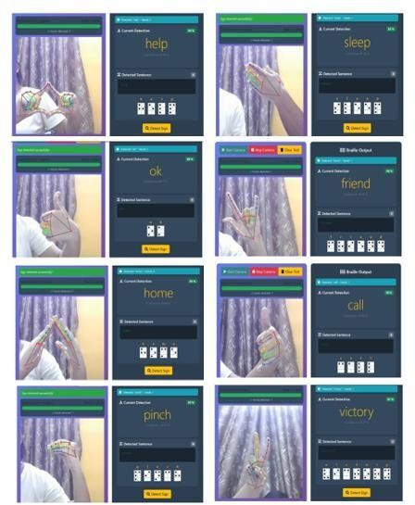

Fig. 10. Real-time gesture recognition using SVM-MediaPipe with corresponding Braille output.

- Comparative Performance of YOLO and CNN Models

Table III presents the results of the YOLO and CNN models tested on the same dataset for comparison. YOLO achieved similar accuracy with slight cross-class confusion but offered significantly faster inference, making it suitable for real-time applications. In contrast, CNN provided higher accuracy and stability due to its strong feature-extraction capability, consistent with findings in prior studies [3], [5], [9], [11]. Overall, the results show that while SVM is computationally lighter than YOLO and CNN, it still achieves competitive accuracy on small-scale static gesture datasets, making it favorable for low-resource environments.
References
- B. Nair et al., "Empowering the Blind School Communities by Recognition of Handwritten Braille Text Documents Using YOLOv5 Technique," in 9th Int. Conf. on Communication and Electronics Systems (ICCES), Mysuru, 2024.
- A. Deshmukh, A. Machindar, S. Lale, and P. Kasambe, "Enhancing Communication for the Hearing Impaired: A Real-Time Speech to Sign Language Converter," in International Conference on Communication and Electronics Systems (ICCES), Mumbai, India, 2024.
- A. Singh, U. Mittal, A. Wadhawan, A. Al Ahdal, M. Rakhra, and Sharma, "Indian Sign Language Recognition System for Dynamic Signs," in 7th International Conference on Communication Systems and Network Technologies (CSNT), Noida, India, 2017.
- D. H. R. et. al., "Evolutionary Strategies for Parameter Optimization in Deep Learning Models," International Journal of Intelligent Systems and Applications in Engineering, vol. 12, no. 2s, pp. 1-6, 2023.
- M. Aly and I. S. Fathi, “Recognizing American Sign Language gestures efficiently and accurately using a hybrid transformer model,” Scientific Reports, vol. 15, no. 1, p. 20253, 2025, doi: 10.1038/s41598-025-06344-8.
- J. Ashwini, L. M. Krishnaa, C. Lakshmipriya, G. Lavanya and S.
R. Subramanian, "Translation System for the Visually Impaired from English to Braille," in 2nd World Conference on Communication & Computing (WCONF), 2024.
- A. Dasgupta, D. Seth, A. Ghosh and A. Nath, "Real-time sign language to Braille interfacing system," in 7th International Conference on Communication Systems and Network Technologies (CSNT), 2017.
- Jeevitha M, Sai Ananya J, Shweta Y, Tejashwini V, Vinutha HV "A Novel Real-Time System for Translating Sign Language into Braille Through Text Intermediation," International Journal of Science, Engineering and Technology, vol. 13, pp. 1-6, 2025.
- R. Deoghare, P. Mahajan, M. Gaikwad, and V. Desale, "Interactive Sign Language Learning Platform Fostering Sign Language Literacy," in IEEE International Conference on Communication, Computing and Automation (ICCCA), Pune, 2024.
- S S. Sharma, R. Sreemathy, M. Turuk, and J. Jagdale, "Real-Time Word Level Sign Language Recognition Using YOLOv4," in International Conference on Futuristic Technologies (INCOFT), Pune, 2022.
- S. Tiwari, Y. Sethia, A. Tanwar, H. Kumar and R. Dwivedi, "An Approach to Real-Time Indian Sign Language Recognition and Braille Script Translation," in 16th International Conference on Signal-Image Technology & Internet-Based Systems (SITIS), New Delhi, 2022.
- Wuyang Qin. et. al, "Sign language recognition and translation method based on VTN," in International Conference on Digital Society and Intelligent Systems (DSInS)., China, 2021.

